February 2011

Safety Matters

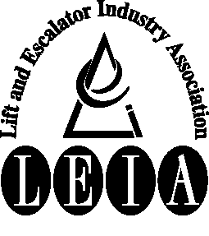
Articles:

• Industry Accidents

• Hazard Awareness

• Maintenance - Polyurethane Buffers

• Training - CSCS Safety Test

• Environmental Awareness

Tel: 020 7935 3013
Fax: 020 7935 3321
Email: enquiries@leia.co.uk
Welcome to the February 2011 edition of Safety Matters.
Through this newsletter our aim is to inform you of health and safety issues that may have an impact on the Lift & Escalator industry. Safety Matters is also available for download from the LEIA member’s website. www.leia.co.uk

Introduction

Industry Accidents

Electrical Safety
Individual companies will have their own procedures for controlling the risks from electricity.
This may include a procedure for isolating the supply, locking it off and checking to verify the equipment is dead (i.e. safe) before working on it.
Where the work cannot be undertaken with the power isolated – usually for the purpose of fault finding or taking measurements, it is essential your own company procedures are followed and if in any doubt consult your supervisor for advice.
Remember:
- Electricity can kill.
- Control voltages can kill.
- Wherever possible isolate, lock off and check equipment is dead before you work on it.
- Where live working is undertaken strictly follow your own company rules.
Hand Arm Vibration
Hand Arm Vibration can lead to damage to the nerves in your hands, wrists and forearms.
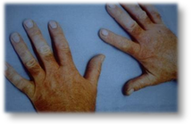
You may have noticed it after using a hammer drill for a prolonged time. In extreme circumstances it can lead to a complete loss of feeling in your fingers (known as ‘White Finger Syndrome’)
At the time of compiling this newsletter we are aware of press reports concerning two fatal accidents involving lift engineers in 2010. There is little we can add to these reports at this time and our thoughts and sympathies are with the bereaved families.

Confined Spaces
Quite often the question is asked “Is a lift shaft a confined space?” The question should really be “Is the lift shaft a confined space risk?”
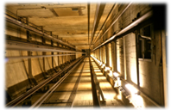
The answer (usually) is no, but beware:
There could be a process unconnected with the lift work going on in the building and if so, there is the possibility of fumes or similar accumulating in the pit pushing out the oxygen required for breathing (e.g. adhesives for floor tiles being used).
If you have any doubts about this, do not take chances, but refer to your company for advice.
LEIA have produced a Safety Information Sheet on the subject which is available from the website.

Photo: Atkins plc
Photo: National Lift Tower

Hazard Awareness

Hand Arm Vibration (cont)
The use of vibrating hand tools must be managed to ensure that limits are set on the amount of time operatives are exposed to vibration.
Management systems are available which can record the time spent on particular tools, the ‘Vibration Dose’ of an individual tool, and the cumulative exposure of an employee.
Each vibrating tool must be assessed to determine its vibration dose; usually manufacturer’s details are available but these must always be treated with scepticism. Laboratory readings may not give the same as ‘real life usage’.
A register must be kept of the exposure of an employee to vibration.
Near Misses – Stop Switch
We have been made aware of several recent near misses involving stop switches which during routine checks were found to be in-operative (for various reasons).
Most companies require these items to be checked routinely as part of their maintenance system both on lifts, escalators and similar equipment. It is essential these checks are made and stops verified as operating correctly.
Maintenance - Polyurethane Buffers
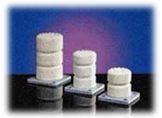
The use of polyurethane type buffers has become increasingly widespread in recent years. With such a simple design and no moving parts it is easy for service engineers to become complacent and think there is nothing to inspect on these devices during a service visit.
This is not the case as these may deteriorate over time to the point where a car impacting the buffer at speed is likely to be severely damaged and occupants may be injured.
Please ensure you inspect these devices at regular intervals determined by planned maintenance to be sure they are not beginning to deteriorate. Those specifying and purchasing these types of buffers should be aware of any environmental limitations contained within the type test certificate e.g. exposure to direct sunlight where lifts are installed into scenic enclosures and subject to UV light exposure.
Training - CSCS Safety Test
In April 2012 CITB are proposing a change to the health and safety test to introduce scenarios where you are questioned about how you would behave in a given situation on site. Each scenario will consist of four questions, with your answers to one question deciding how the next question will be phrased. The overall number of questions will remain the same and you will still be asked about general health and safety.
This introduces an element of behavioural safety into the test that was not there before, where you were simply tested on your health and safety knowledge, not how you are likely to actually behave on site.
Environmental Awareness
Hazardous Chemical Labelling
A new European regulation on the Classification Labelling and Packaging of Substances has been introduced. This will revise the form of hazard symbols or pictograms seen on many chemicals. It also introduces new wording to help you understand the hazards on the chemical you are using, and advice on how to use it safely. The new pictograms are starting to be used now, so you may see them on substances you are using.
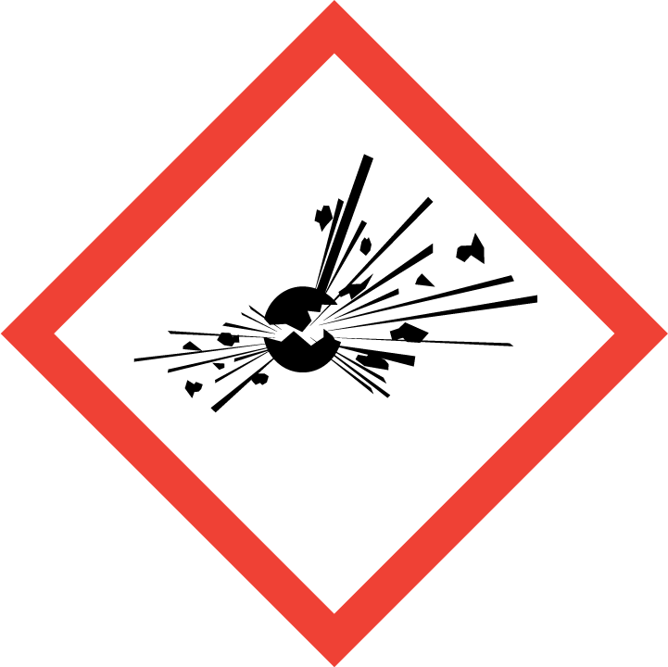 | 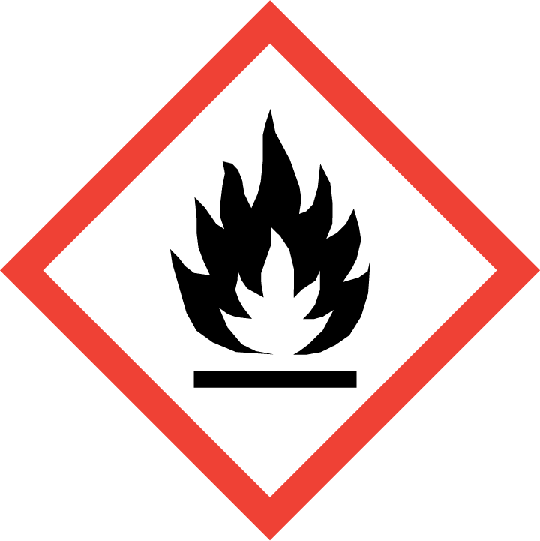 | 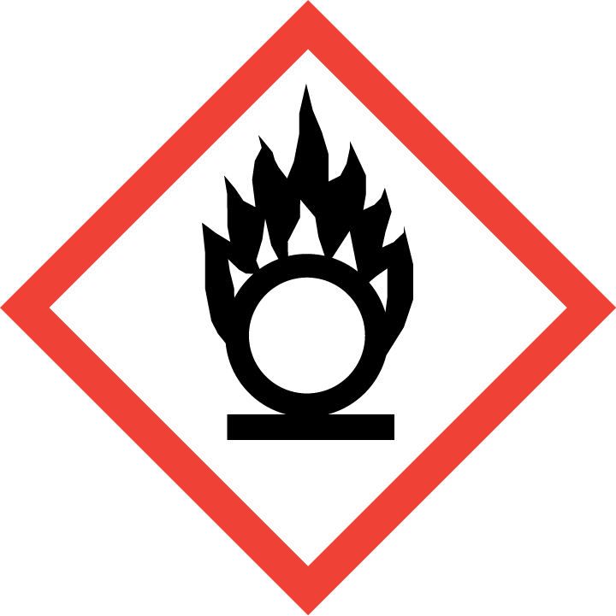 | 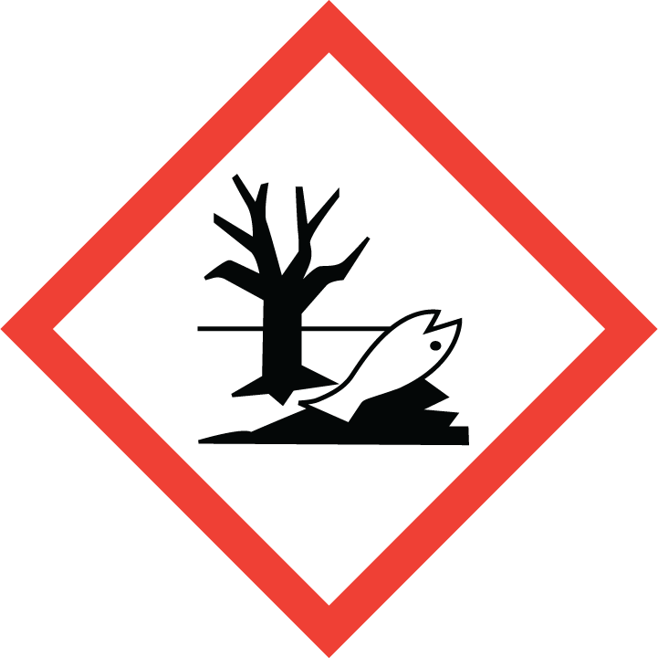 | 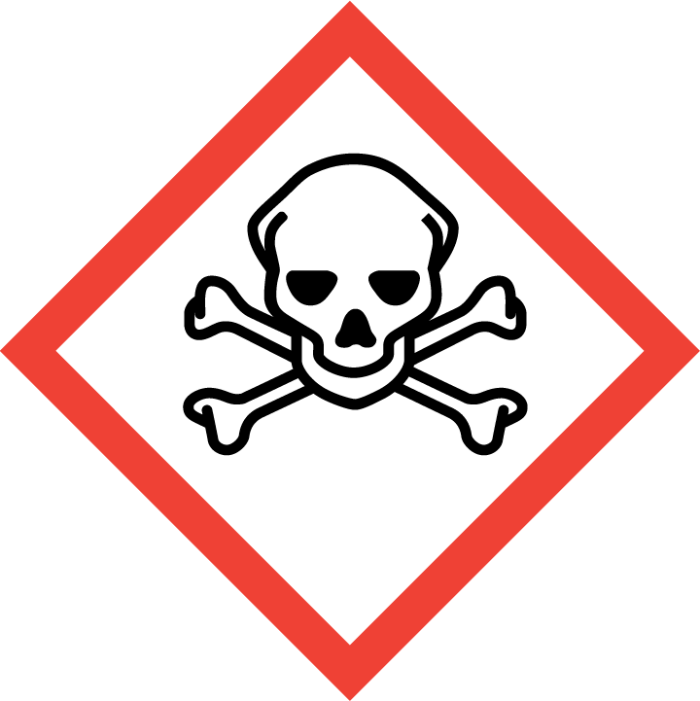 | 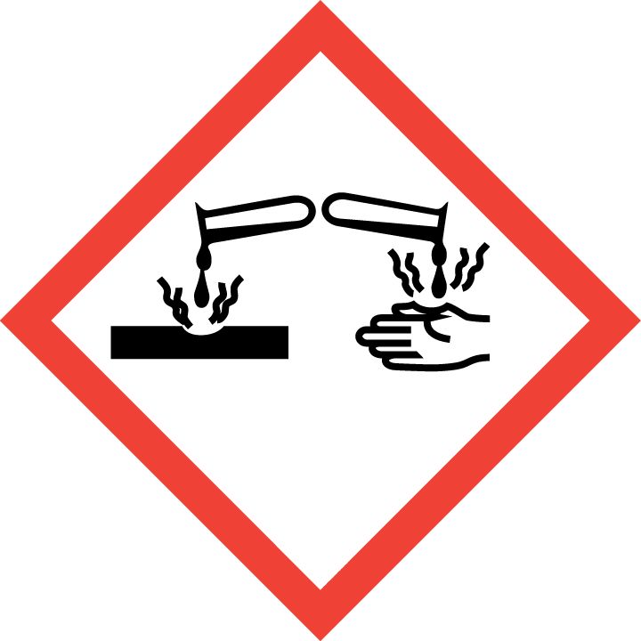 | 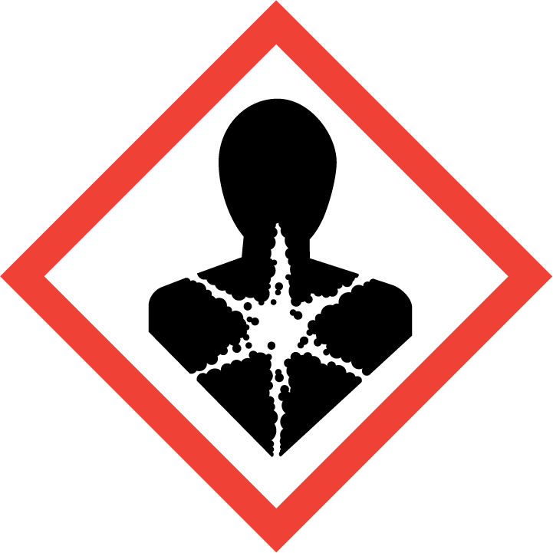 |  | 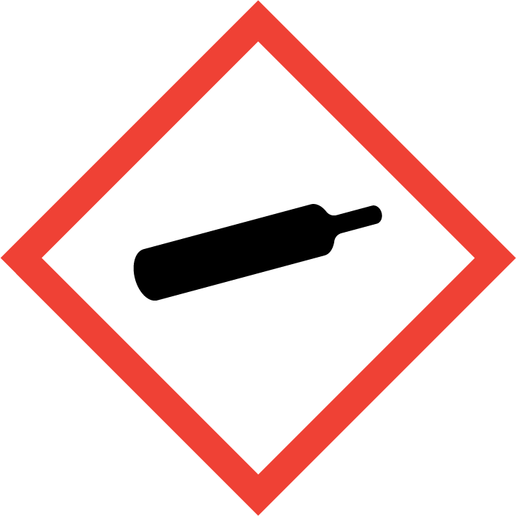
Explosive | Fire Risk | Oxidiser | Pollutant | Deadly | Corrosive | MajorHealth Hazard | Health Hazard | Compressd Gas
Skip Labelling
See HSE document INDG 350 for descriptions
New labelling for waste skips on site is being proposed. This will make it easy to identify the type of waste to put in each without relying on wording which can be misunderstood. The labels are as follows:
White Label – plaster waste
Green Label – wood/timber waste
Blue Label – metal waste
Orange Label – hazardous waste
This will assist with the government’s plan to reduce the amount of waste sent to landfill. It will also enable the easier recycling of waste material and reduce the cost of waste sent to landfill.
Burnt battery as a result of being shorted out

